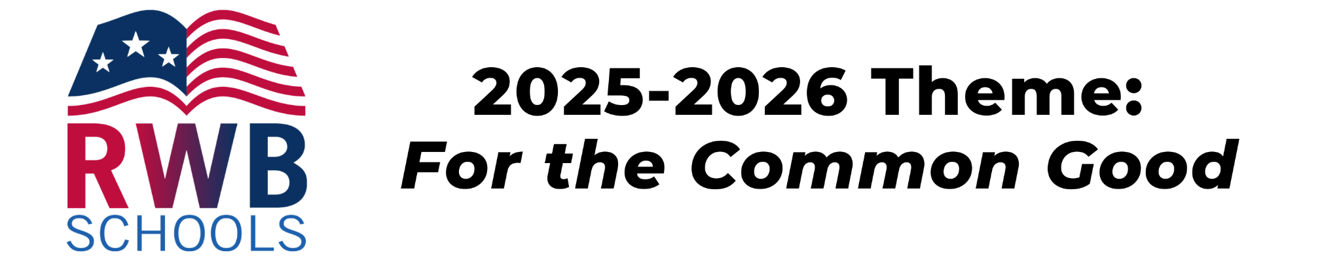

2025-2026 Red, White & Blue Schools Application for Recognition
Complete the following application to be considered for Red, White & Blue Schools recognition!

In all answers, be sure to make connections to this year’s theme, “For the Common Good”. You may include links to images / graphics / photos, or you can email accompanying materials to info@rwbschools.org.

Submit this form and any accompanying materials by Friday, April 24, 2026. Outstanding Schools will be notified to schedule an awards presentation.

Applicant Details
I am submitting as a (SELECT ONE):
- School District
- School
- Grade Level
- Combination of two or more classes
- Individual classroom

Name of School District:
Name of School(s):
Grade(s) or Course(s):

Contact Name and Position:

Contact Email:

Contact Phone:

School Mailing Address:

Community partners/collaborators (if applicable):

Project(s) – Please provide the following information. In all answers, be sure to make connections to this year’s theme, “For the Common Good”. You may include any images / graphics / photos in these sections below, or you can attach a separate document.

Executive Summary: Describe what students did for the submitted project/activities. How does this work promote student understanding of the connection between people, their community, and government? How did the work involve students using their voices, or understanding how others used their voices, to make change?

- Explain how your submitted activities align with the Connecticut Elementary and Secondary Social Studies Standards, specifically civics and inquiry.

- Explain how the submitted activities promote the voices of various members of the relevant community (class, school, neighborhood, town, etc.) being discussed (through primary documents or interactions with people).
- Describe how the topics and activities conducted by students are relevant to individual students and help them understand the role of government in their daily lives and community. Include if students had a role in planning activities and what they did.
- Explain how the submitted activities demonstrate the ways that a community may be impacted by, and can influence, government decisions. Include if students took direction action to make a change, and the outcome of how the project or activities impacted a community.
- Explain why you selected the type(s) of presentation formats to express the theme. Provide context for any images or documents that you are sharing.

- Please include any applicable links in this area. These might be to community groups involved, portfolios of student work, images of students doing the activities, etc. You may also include attachments in the email when you sending your submission.

